Dhani App sentiment report for 1 year data

# Overall Summary

* App name: Dhani
* Number of reviews analyzed is 1,86,080
* Total number of reviews after cleaning the data is 78,285
* Timeline of reviews: 01 January,2020 to 21 January,2021 (386 days)

## Comparison of Aspects depending on how many numbers of people are writing about the aspect.

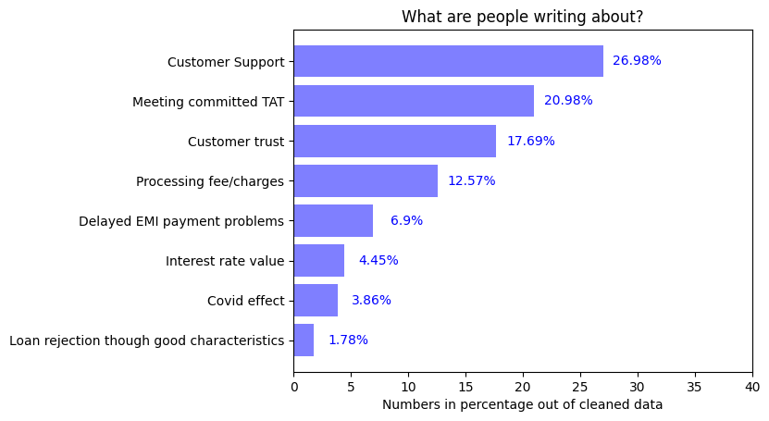

## Comparison of Aspects depending upon average rating given by users:

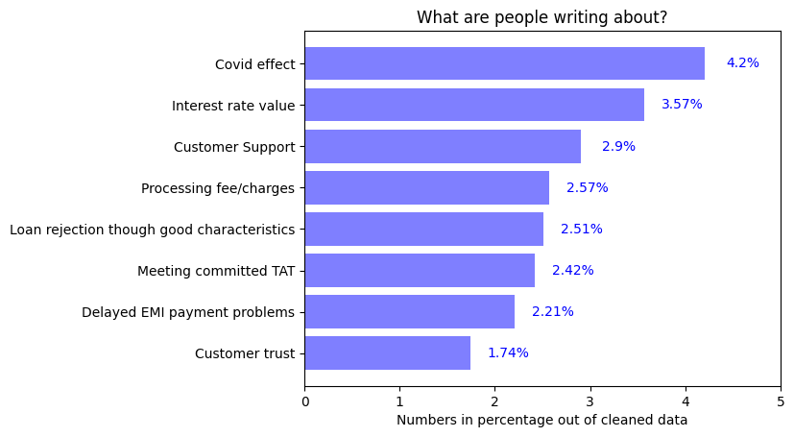

### Inference:

1. Large number of people are writing about meeting committed TAT and Customer support so it is an important point from users’ perspective
2. Reasonable number of people have written about Customer trust and it has very low average rating. Possible reasons for this are:
   1. Spam messages
   2. Not getting loan at all
   3. False promises
   4. App not working as expected

# 1.Appropriate Interest rate

* Percentage of people writing about this topic is 4.45%
* Average rating given by users for this aspect is 3.57 out of 5
* 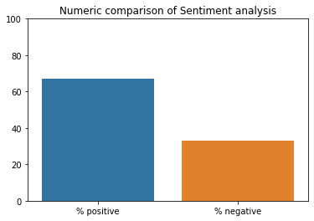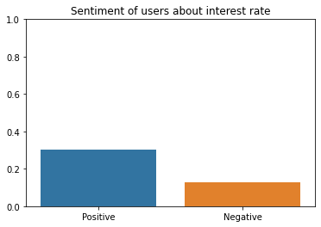Sentiment Analysis:

Figure 2: This shows how many people are positive or negative about this aspect

Figure 1: This shows Intensity of negativity or positivity of sentiments

### Inference:

1. People are more positive than negative about interest rate
2. Large number of people are Positive about interest rate and it matches the industry standards, people are happy about it
3. As compared to 4 months analysis users were happier about interest rate previously but their sentiment became more negative during the latest 4 months.
4. Clearly, rating given by users has depreciated for the last 4 months as compared to average rating for the 1 year

* Further Insights:

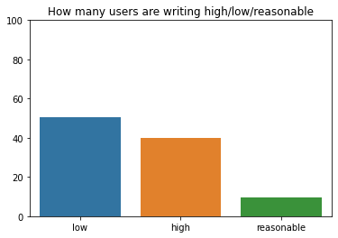

People saying interest rate is low =50.43%

People saying interest rate is high=39.92%

People saying interest rate is reasonable=9.63%

We see that the app has increased their interest rate during the last 4 months compared to industry standards

# 2.Delayed payments of EMI

* Percentage of people writing about this topic is 6.90%



* Average rating given by users is 2.21 out of 5
* 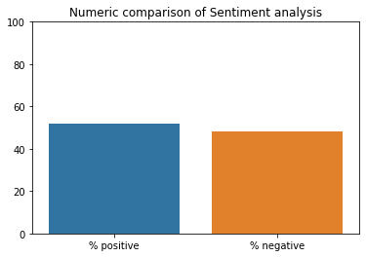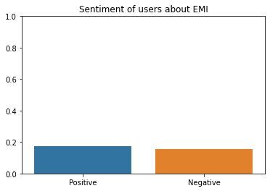Sentiment Analysis:

Figure 1: This shows Intensity of negativity or positivity of sentiments

Figure 2: This shows how many people are positive or negative about this aspect

### Inference

1. People are equally positive and negative about the EMI
2. Equal number of people are writing positive as negative about EMI
3. We see that the performance of app on this aspect has also depreciated in the last 4 months as we compare average rating and % negative count for 1 year and 4-month data
4. Possible reasons:
   1. If user is late to pay an instalment then she/he is unable to get loan again
   2. Customers are not happy about EMI payment service in app
   3. Even after paying outstanding loan app didn’t give NOC certificate

# 3. Loan rejection though good characteristics

* Percentage of people writing about this topic is 1.78%



* Average rating given by users is 2.51 out of 5
* Sentiment analysis:

### 

Figure 2: This shows how many people are positive or negative about this aspect

Figure 1: This shows Intensity of negativity or positivity of sentiments

### Inference:

1. People are writing equally positive as well as negative about loan rejection
2. The number of users writing about this topic is low.

# 4. Customer queries / grievances support services:

* Percentage of users writing about this topic is 26.98%



* Average rating for Customer support is 2.90 out of 5
* 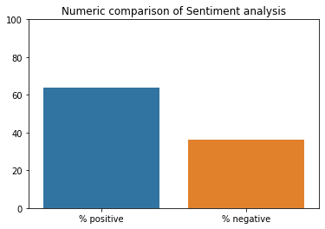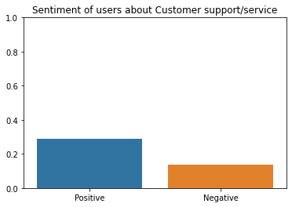Sentiment Analysis:

Figure 2: This shows how many people are positive or negative about this aspect

Figure 1: This shows Intensity of negativity or positivity of sentiments

### Inference:

1. Users are more positive about Customer support
2. Almost 60% people are satisfied with the customer support service
3. More than 25% of users have written about this aspect

# 5.Processing Fee/ Extra Charges:

* Percentage of People writing about this topic is 12.57%



* Average rating for this topic = 2.57 out of 5
* Sentiment:

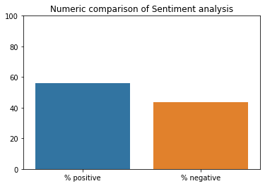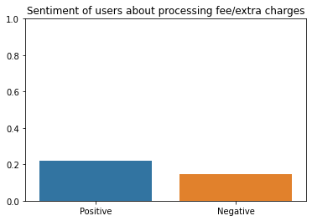

Figure 2: This shows how many people are positive or negative about this aspect

Figure 1: This shows Intensity of negativity or positivity of sentiments

### Inference:

1. Users are more positive about processing fee/charges
2. 60% of people are happy about this so they are along the industry standards
3. The view of users about this aspect has become more negative during the last four months as seen in the 4-month data

# 6. Loan disbursal to customer meeting the committed TAT

* Percentage of users writing about this topic is 20.98%



* Average rating by users is 2.42 out of 5
* 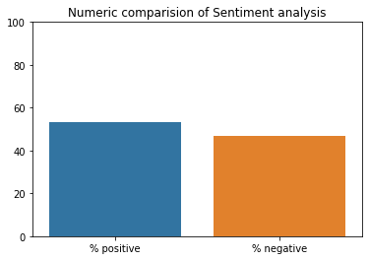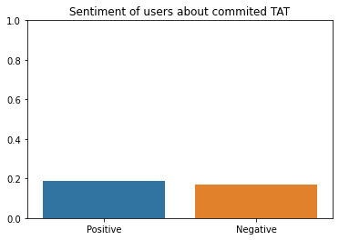Sentiment:

Figure 2: This shows how many people are positive or negative about this aspect

Figure 1: This shows Intensity of negativity or positivity of sentiments

### Inference:

1. Sentiment of users about TAT equally positive and negative
2. Almost 20% users have written about this aspect out of which almost 45% are not satisfied

# 7.Trust / legal/ fraud issues with app

* Percentage of users writing about this topic is 17.69%



* Average rating by these users is 1.74 out of 5
* 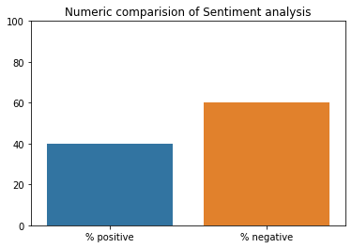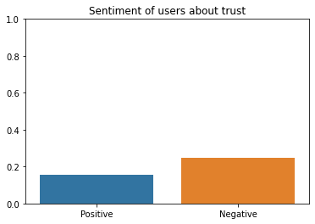Sentiment:

Figure 2: This shows how many people are positive or negative about this aspect

Figure 1: This shows Intensity of negativity or positivity of sentiments

### Inference:

### About 18% of users have written about trust on the app

### Out of which 60% users have suspicious view about the app while others are satisfied of its services

# 8.Covid-19 effect

* Percentage of users writing about this topic is 3.86%

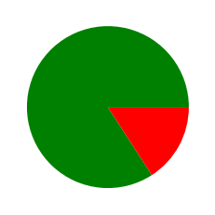

* Average rating by these users = 4.20 of 5

* 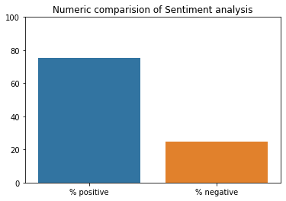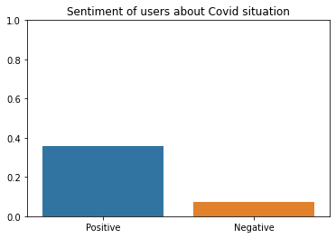Sentiment analysis:

Figure 2: This shows how many people are positive or negative about this aspect

Figure 1: This shows Intensity of negativity or positivity of sentiments

### Inference:

1. The services given by the app in covid-19 pandemic times are satisfactory completely
2. As, more than 70% of users are unhappy about the service provided in this period